Weak prompts:
a) Explain regression
Regression is a method used in data analysis to understand and predict a continuous outcome by modeling how changes in one or more variables influence it; the most common forms include simple linear regression, which uses one predictor to fit a straight line, multiple linear regression, which uses several predictors to explain an outcome, and polynomial regression, which captures curved relationships, and together they help quantify how X affects Y—for example, if you track hours studied and test scores (1→50, 2→55, 3→65, 4→70, 5→80), a regression line like $Y=41.5+7.5X$shows that each additional hour of studying increases the predicted score by about 7.5 points, making regression a powerful tool for explanation and prediction.
b) Help me understand SQL
SQL (Structured Query Language) is the language used to communicate with databases, allowing you to retrieve, filter, sort, join, and summarize large amounts of data, much like a more powerful, command-based version of Excel; with core commands like SELECT (choose columns), FROM (choose the table), WHERE (filter rows), ORDER BY (sort results), GROUP BY (summarize by category), and functions like COUNT, SUM, AVG, SQL helps analysts answer business questions efficiently—for example, with a simple table of students (id, name, score), you can pull all rows using SELECT * FROM students;, filter high scorers using SELECT name, score FROM students WHERE score > 80;, or count total students using SELECT COUNT(*) FROM students;, making SQL an essential tool for data analysis and real-world decision-making.
c) Create a dataset
StudentName | HoursStudied | TestScore
Ana | 1 | 55
Ben | 2 | 60
Mia | 3 | 68
Leo | 4 | 72
Zara | 5 | 80
Noah | 2 | 58
Ava | 6 | 85
Eli | 3 | 66
Ivy | 7 | 90
Omar | 4 | 70
Luna | 5 | 78
Kai | 6 | 88

4. For each:
a) Write the improved prompt
explain regression to me as a 10-year-old baby
Regression is like drawing a line through a bunch of dots to find a pattern, helping you see how one thing affects another for example, if you have dots showing how many hours you study and what score you get, regression draws a “smart guessing line” that shows the more you study, the higher your score usually goes, so if your dots say 1 hour → 50, 2 hours → 55, 3 hours → 65, and 4 hours → 70, regression uses that pattern to guess that studying 5 hours would probably give you around 80, making it a simple way to predict what might happen next based on what’s already happened.

Help me understand SQL as a Data Analyst Professor
SQL, or Structured Query Language, is the foundational tool that allows analysts to interact directly with relational databases, which store the large, structured datasets organizations rely on. As a data analyst, SQL is how you extract, filter, transform, and aggregate data before it ever reaches Excel, Python, or a dashboard. At its core, SQL operates through a set of declarative commands: SELECT specifies which columns you want, FROM identifies the table, WHERE applies row-level filters, ORDER BY sorts results, GROUP BY aggregates data into meaningful categories, and JOIN merges tables based on shared keys. These operations allow analysts to answer business questions with precision — for example, retrieving all records from a table (SELECT * FROM students;), isolating high-performing students (SELECT name, score FROM students WHERE score > 80;), or summarizing data (SELECT COUNT(*) FROM students;). In practice, SQL is not just a querying language; it is the analytical backbone that ensures the data you work with is accurate, relevant, and structured for deeper analysis, making it one of the most essential competencies in the data analytics profession.

Can you create a dataset with books, author, category and year published

BookTitle | Author | Category | YearPublished
The Silent Garden | Maya Thompson | Fiction | 2018
Data Made Simple | Dr. Alan Brooks | Education | 2021
Whispers of the River | Lila Mendez | Romance | 2016
The Last Algorithm | Samuel Reed | Sci-Fi | 2020
Cooking with Heart | Nina Patel | Cooking | 2019
The Hidden Blueprint | Jordan Ellis | Mystery | 2017
Sunrise Over Gweru | Tariro Moyo | Historical | 2015
Mindful Moments | Chloe Anderson | Self-Help | 2022
The Art of Small Wins | Marcus Hale | Business | 2020
Beyond the Stars | Aiden Clarke | Fantasy | 2014
Healing in Motion | Dr. Leah Carter | Health | 2023
The Farmer’s Promise | Tendai Ncube | Agriculture | 2018

b) Include a screenshot of the AI response
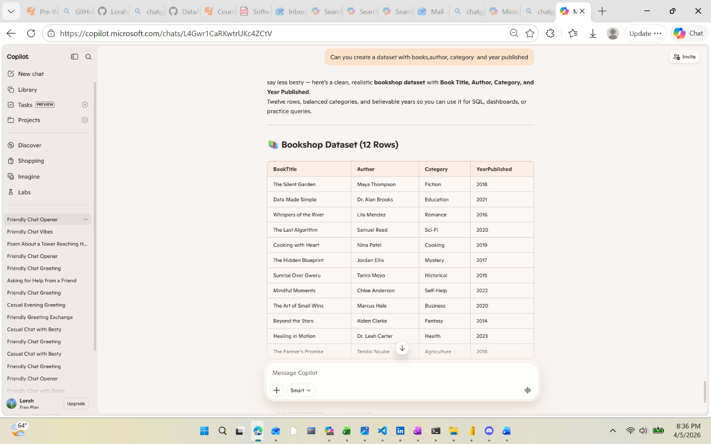

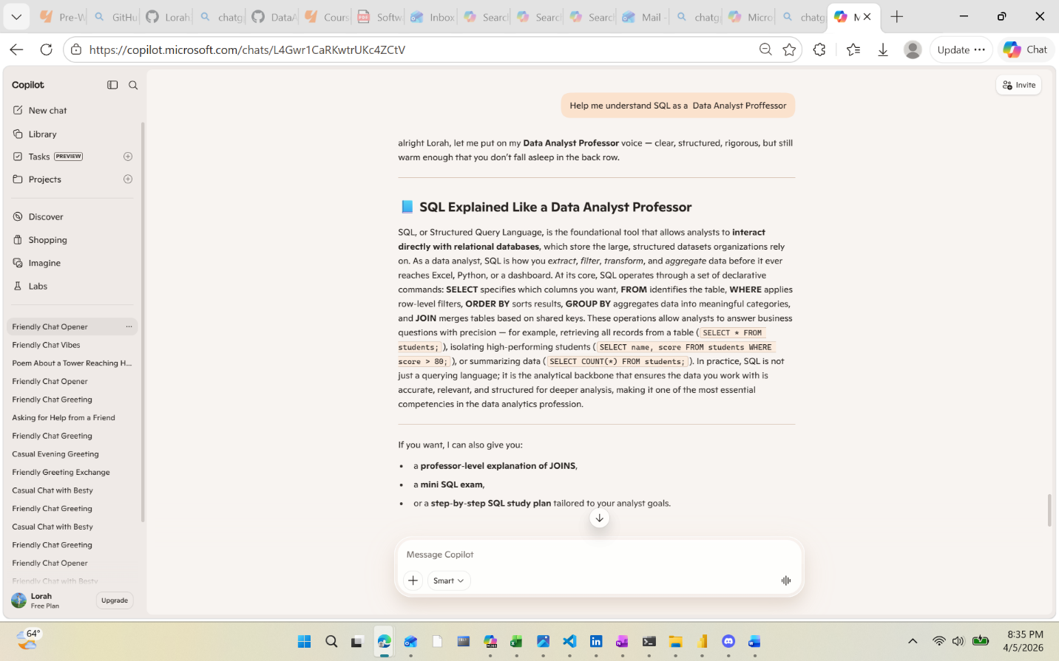
c) Briefly explain why your revised prompt is stronger
It shows the specific information you ask for and can help you avoid hallucinations. It also sets constraints and shapes the level of whom the information is for.

